**Rathburn/Ponytrail I.P**

Below is the City's response to the issues raised by the RRA concerning the Rathburn/Ponytrail I.P., including their action plan for resolution.  Plans to replace the tree canopy affected by the bicycle lanes and the boulevard plantings.

**Concrete pad adjacent to Logos.**

* + I (Councillor Fonseca) have reconfirmed that this is for bike storage.
  + The contractor has confirmed that the bike racks will be installed next week.
* **Bough Beeches crosswalk** (at the end that is closer to the cul-de-sac)
  + This intersection will be an all-way stop. Locates have been initiated for the installation of the stop signs. A work order has been prepared and will be issued once the locates are complete. Locates can take a few weeks to obtain, but staff have this as a priority.
  + Crosswalk painting will be weather dependent, but will be completed once the stop signs are installed.
* **Post-construction speed/volume studies**
  + Once the final site works/restoration are complete, and the all-way stop is installed, staff will conduct the post-construction speed/volume studies.
  + The studies should be complete and the results available before the end of summer.

 As noted on the website, the following provides an overview of the final site works/restoration to be completed by the contractor this spring:

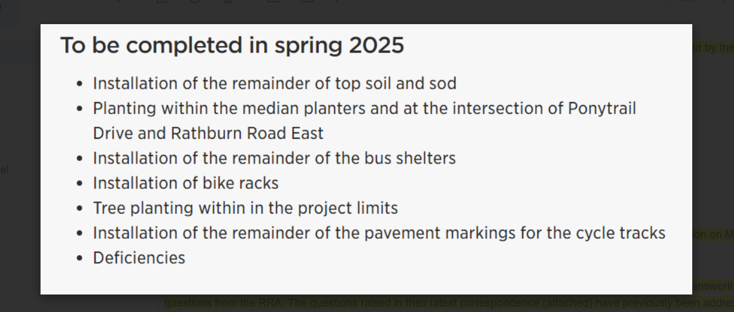

As also requested, I have attached the presentation that was presented to the Rockwood Resident Association on March 26th. This was also emailed directly to the President of the RRA (Dale Biason) on April 7th.

Attachment on our website – link to Rathburn Ponytrail Presentation

As discussed yesterday, through collaboration with your office, staff have spent a significant amount of time answering questions from the RRA. The questions raised in their latest correspondence (attached) have previously been addressed, but we recognize that they are still not satisfied. To assist, staff have compiled a consolidated response for each theme for your use as needed:

1. **Community Consultation**

At the March 26th meeting we reviewed the planning process that was undertaken by City staff – namely the Municipal Class Environmental Assessment process, which is undertaken by municipalities within Ontario for transportation, water and wastewater projects. As part of the EA process, we completed a robust Community Engagement Plan, including virtual Community Meetings on January 22 and June 9, 2021. In addition, we met with the RRA on May 26, 2021, November 5, 2024 and March 26, 2025.

Throughout the planning process, comments and feedback were received and taken into consideration, including the public, as well as internal/external stakeholders, utilities, etc. This includes the areas of traffic operations, safety, active transportation, urban design, forestry, stormwater management, streetlighting, asset management, MiWay, etc. To help guide our decision-making process, we followed approved City policies and guidelines (i.e. Vision Zero Action Plan, Cycling/Pedestrian Master Plans, Changing Lanes/Complete Streets, etc.), as well as geometric design standards and guidelines (i.e. Transportation Association of Canada, Ontario Traffic Manuals, etc.). The Project Team took all comments received into consideration and completed an evaluation, which identified the recommended solution.

2. **Future Feedback**

The project is nearing completion. Moving forward, like other roads in the City, if residents have concerns with operations or maintenance, they can contact their Ward Councillor or call 311 to generate a service request, which will be sent to the appropriate staff team in Traffic Operations or Works Maintenance to review/respond.

**3. Construction Safety Oversight**

In accordance with City contracts and provincial law, construction contractors are responsible for site safety.  When hiring construction contractors for projects of a magnitude such as this, contractors must meet certain requirements, such as experience with similar projects.  Contractors are also required to submit a health and safety plan before construction commences and comply with all applicable health and safety laws and regulations during construction.

If a contractor is found to be in breach of their responsibilities, the City may pursue various remedies which include but are not limited to requiring corrective action, reporting to relevant authorities, withholding payment and/or terminating the contract.